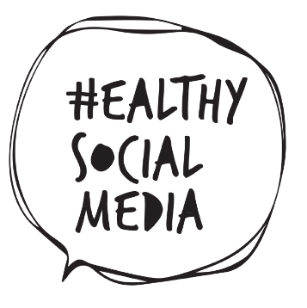

**What will be after the Healthy Social Media project?**

With the Healthy Social Media project coming to an end, several ideas have been developed for how the results can be taken forward into the future. The project’s website will be enacted for another 3 years, extending this way the availability of the resources. Work with skills will still be developed and online ambassadors will be used to cascade information to younger members and within the school. It is important to help keeping the youth as safe as possible in the digital environment because besides the positive impact of social media, we have to acknowledge there are also going to be negative impacts and it is important to make sure that their health and well-being will be looked after. The Healthy Social Media project partners will be looking to see how they can best relate the project within their areas.

*“Helping make young people’s experience of using social media a healthy, positive and life affirming one!”*











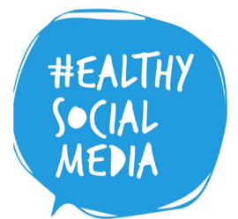

**Healthy Social Media Website**

The Healthy Social Media unique website is generating a lot of interest in recent times. It is constructed as a vital platform to enables visitors to learn more about the project. This user-friendly website also contains a lot of useful resources which are absolutely 100% free and include the following:

* Healthy Social Media Needs Analysis Study
* Healthy Social Media Open Educational Resources

**www.healthysocialmedia.eu**

**Healthy Social Media Course**

The [course](http://www.healthysocialmedia.eu/teaching-resources/) is designed to be delivered in a group setting by youth workers and educators and for those involved in non- profit youth organisations, Education & Training and policy makers. It seeks to equip young people with the knowledge to use and enjoy social media in a positive manner, and to become responsible digital citizens.

The materials are designed for various uses. The course can be delivered as a complete curriculum or parts of it might be integrated to supplement other courses. All materials are provided as open source and each section of this course offers a variety of additional materials such as videos, case studies and activities about the topic.

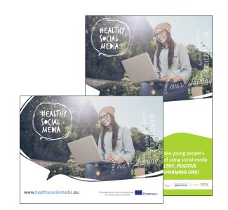

*“Helping make young people’s experience of using social media a healthy, positive and life affirming one!”*

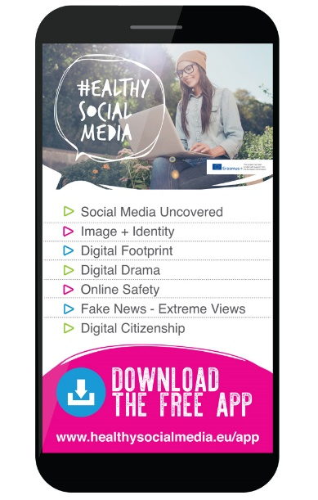

**What do experts think about the HOME educational resources?**

Some experts have evaluated the HOME educational resources underlining its accessibility for young people. For instance, the HOME App is considered to be ‘’modern, up-to date and delivered in a technological way’’, managing to engage young people in technology as they are learning about technology.

Furthermore, the resources that have been developed for teachers are very hands-on and practical. On the other hand, the Healthy Social Media project has been highlighted as a very good best practice example on how to foster critical thinking amongst children and young people. The App is exactly what young people want – something funny and creative that can be used at the same time to educate them.

You can find more about experts’ opinion [here](https://www.youtube.com/watch?v=GA4LuLjgOxw&t=3s).

**Healthy Social Media App**

We are currently finalizing HOME App which will be based on the open educational resources (IO2) and will be designed to be used both as a stand-alone app and also as an additional resource to complement and reinforce the OERs developed in IO2. The next step after completion and final review is getting it online.

This mobile app for iPhone, iPad and Android devices will be designed specifically for young people and will promote healthy social media usage and the development of critical thinking skills. It will significantly improve the ability of young people to critically assess and engage with the digital and social media they are consuming and creating in a way that favours their empowerment and active citizenship. HOME App will be live and available for download in December 2018.

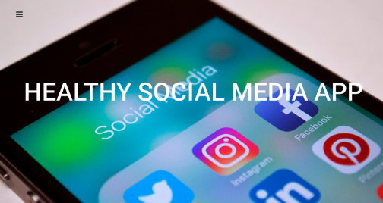

**Healthy Social Media Final Multiplier Event**

#### The [Final Event](https://www.efvet.org/2019/03/29/helping-make-young-peoples-experience-of-using-social-media-a-healthy-positive-life-affirming-one/) of the [Healthy Social Media Project](https://healthysocialmedia.eu/) ‘’Helping make young people’s experience of using social media a healthy, positive & life-affirming one’’ was organised by EfVET on the 27th March. The conference explored how we can promote a healthier use of social media among younger generations.

#### The event included presentations about the project’s outcomes, teaching resources and tools from project’s partners. A panel discussion followed focused on the importance of developing critical thinking skills to promote Healthy Social Media use for digital empowerment.

#### The event counted on:

#### Julie Jamieson, New Lodge Duncairn Community Health Partnership - Introduction to Healthy Social Media Erasmus + project

#### Canice Hamill, Canice Consulting Limited - [Presentation of the Teaching Resources (OER)](https://www.efvet.org/wp-content/uploads/2019/03/Canice_Module-1healthysocialmedia_powerpointMODULE1.pdf)

#### Sonia Naiba, Momentum Consulting - [test of Healthy Social Media App](https://www.efvet.org/wp-content/uploads/2019/03/MMS-HOME-App.pdf)

#### Sue Bird, European Commission, DG-EMPL, VET, Apprenticeships & Adult learning - [Latest news in Education and Training European Vocation Skills Week](https://www.efvet.org/wp-content/uploads/2019/03/Sue_Presentation-to-Healthy-Social-Media-March-2019.pdf)

#### Sabrina Vorbau – Project Manager (eSafety Team) at European Schoolnet

#### Paloma Cantero-Gomez– Director of European Affairs at iCMEDIA

#### Manuel Bordoy Verchili -Director at European School Brussels IV (Laeken)

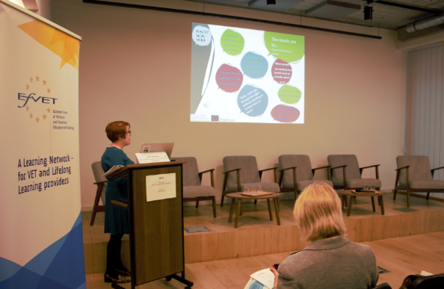



*“Helping make young people’s experience of using social media a healthy, positive and life affirming one!”*

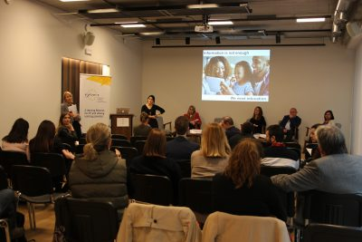

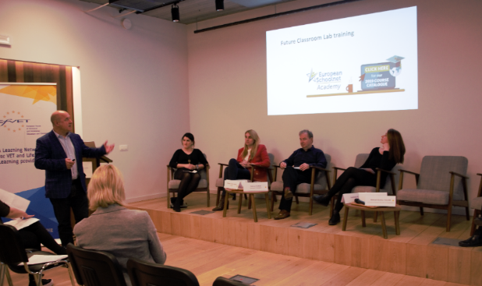

**www.healthysocialmedia.eu**



**/HealthySMedia**

**@HealthySMedia**



**HOME Multiplier events**

[Here](https://www.youtube.com/watch?v=XMwRPbVwflg&feature=youtu.be) you can find a summary of the Healthy Social Media project events developed across the partners’ countries.

* New Lodge Duncairn Community Health Partnership – UK
* Momentum Consulting, Ireland
* Drustvo SPES, Slovenia
* INDEO , Spain
* EfVET, Belgium

*“Helping make young people’s experience of using social media a healthy, positive and life affirming one!”*

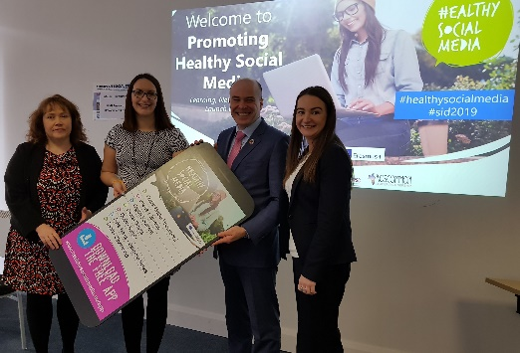

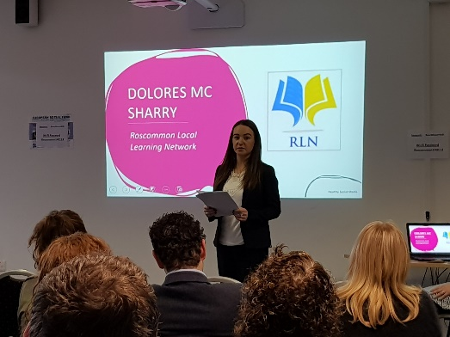

**News items:**

* **Agreement reached on digital copyright rules,** [**European Parliament**](https://www.europarl.europa.eu/news/en/press-room/20190212IPR26152/agreement-reached-on-digital-copyright-rules?fbclid=IwAR1i9lAFnMGiHgpCZajpEkzZE5M9q0hGi72NclM8riRfehD85qrCy3AWLWg)