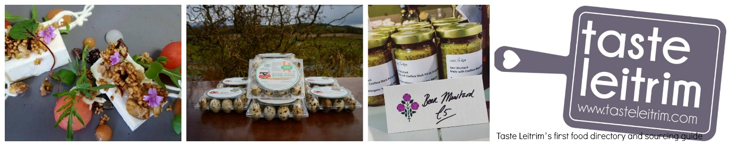

Call out to all local food producers and growers in County Leitrim.
Application to Join:
The Taste Leitrim Directory /Sourcing Guide.
This will be a one stop publication where buyers, chefs, and the wider food business sector both inside and outside of the County can easily access locally sourced quality food products.
From farms to butchers, organic growers to sourdough bakers, small batch producers of preserves, sauces and dressings to local honey producers and chocolatiers, sushi and fresh seafoods to dairy ice-cream, Kefir and cheese, to craft beers and gin distilleries and coffee, we have a wealth of produce that we want to bring to the fore on menus across Leitrim and further afield.

Want to join? Apply now – it’s free!

Your Name_________________________________________________________________________
Your Email_________________________________________________________________________
Your business
Please complete all fields below to tell us about your business. This information will be used as your business profiling in Taste Leitrim’s first food directory and sourcing guide.
Company Name_____________________________________________________________________
Company Address___________________________________________________________________
Company Telephone_________________________________________________________________
Company Email_____________________________________________________________________
Company Website___________________________________________________________________
100-word introduction to you and your products: Please give as much detail as possible, for example, how you make your products, ingredients used, seasonality, farming practices etc.

Where are your products stocked?
Please tell us where your products are currently sold. (Tick all that apply)
- Farmers' Markets
- Farm Shops
- Food Festivals
- Delicatessens
- Independent Retailers
- Major Retailers
- Online Shops
- Your Website Shop
- From Your Premises
- Direct to Restaurants
We are creating a calendar of Food events for the coming year please indicate here if you are able to host one food related event per year.

The Sourcing Guide is one of key actions to be launched in the Autumn as a follow up to the recently launched Leitrim Food Strategy 2017-2021. Other actions include the launch of the Taste Leitrim network and the publication of a Taste Leitrim Visitor Trail brochure.
Momentum Consulting is now working on compiling the Sourcing Guide, please contact Gillian on 071 9623500 for further information and return this short application form to us at design@momentumconsulting.ie to get involved.
How and when will we get back to you?
We aim to respond to your application with 3 working days and will send you an email to process your application.
Thank you for getting in touch.

