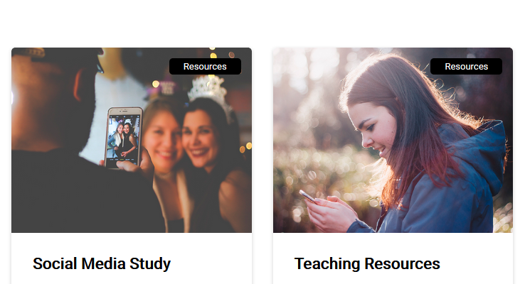
Healthy Social Media Website
The Healthy Social Media unique website is generating a lot of interest in recent times. It is constructed as a vital platform to enables visitors to learn more about the project. This user-friendly website also contains a lot of useful resources which are absolutely 100% free and include the following:
- Healthy Social Media Needs Analysis Study
- Healthy Social Media Open Educational Resources
You can find any of this information on our website: http://www.healthysocialmedia.eu

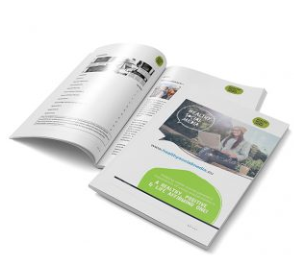
Healthy Social Media Needs Analysis Study
The purpose of the study is to identify the health-related factors and potential negative experiences and outcomes associated with current adolescent social media over-use across parts of Europe. A key challenge today is learning how to adapt to this new environment, to learn to balance online and offline activities, and to get the best out of the digital world we are now in. In our Healthy Social Media research project we have examined the potential detrimental effects of social media on the personal, social, and professional lives of the users. Please check our website to download the Needs Analysis Study: http://www.healthysocialmedia.eu/social-media-study/

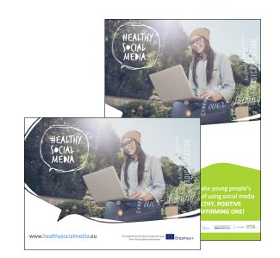
Healthy Social Media Open Educational Resources
A key challenge today is learning how to adapt to this new environment, to learn to balance online and offline activities, and to get the best out of the digital world we are now in. With that challenge in mind the Healthy Social Media project has developed a comprehensive set of open education resources to raise awareness of the digital dynamics and attitudes in play, and to help guide and empower our youth in developing and maintaining healthy social media practices, and to become responsible digital citizens. The syllabus of the Healthy Social Media course is divided into eight different modules, each of them focusing on different aspects of social media usage and consequences:
Social Media Uncovered, Self-Image, Identity and Social Relationships, Digital Footprint and Reputation, Digital Drama and Conflict Resolution, Privacy, Security and Safety, Fake News and Extreme Views, Information Literacy and Critical Thinking, Responsible Digital Citizenship.
You can download the Open Educational Resources at: http://www.healthysocialmedia.eu/teaching-resources/
Healthy Social Media App

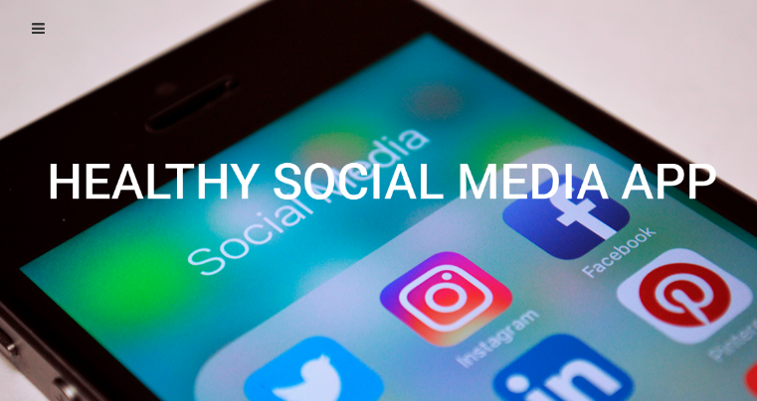
We are currently finalizing HOME App which will be based on the open educational resources (IO2) and will be designed to be used both as a stand alone app and also as an additional resource to complement and reinforce the OERs developed in IO2. The next step after completion and final review is getting it online.
This mobile app for iPhone, iPad and Android devices will be designed specifically for young people and will promote healthy social media usage and the development of critical thinking skills. It will significantly improve the ability of young people to critically assess and engage with the digital and social media they are consuming and creating in a way that favours their empowerment and active citizenship. HOME App will be live and available for download in December 2018.

HOME Benefits

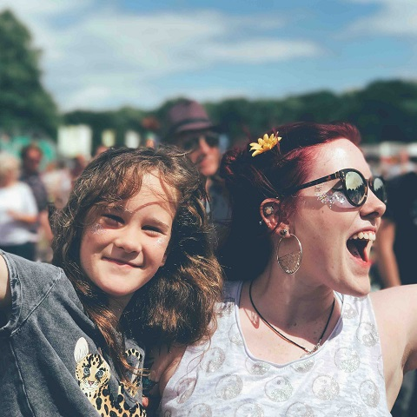
Healthy Social Media has been carefully structured to empower young people to critically assess social media and interact more responsibly online, in a way that safeguards their own wellbeing as well as actively contributing to that of others and society in general. By engaging with our project, Youth Workers, Educators and Young People will benefit from:
- improved understanding of the negative aspects of social media usage which can pose a risk to the mental and physical health, attitudes and beliefs (radicalisation) of young people.
- new ways of engaging with hard-to-reach young people, often from disadvantaged backgrounds.
- access to best practice policy tools and teaching strategies to catalyse learning on the effects and impacts of Social Media for responsible and active citizenship.
- increased confidence in their ability to use social media in a healthy and appropriate manner.
- more highly developed critical thinking skills, enabling young people to critically evaluate their position while participating in the social, cultural and political aspects of society.
- greater awareness of the potential impact of social media as a double-edged sword, one that can erode confidence, impair interpersonal relations, create online peer pressure and abuse and alter values and beliefs.

